**Week 3 and week 4 Assignment** –**Symmetrical** **Balance and Asymmetrical Balance**- Read the handout on Balance in Art and Design. Go out into your yard into nature (of course practicing social distancing) or find interesting things around your house and take photographs of objects that catch your eye and demonstrate **symmetrical** and **asymmetrical** balance. **\*Note\*** you are required to take 2 photographs for each type of balance. The 1st photo is your composition, the 2nd photo (Evidence Photo) is your composition with a piece of paper in it that includes your name and the type of balance it uses. Please make sure that you take time and consider the ideas in the handout when creating your composition and that is evident that time was spent and careful consideration was taken when your art was being made. Most likely you will have to take numerous photos and then choose your best ones to turn in for a grade. \***If you do not have the technology available to take a photograph and turn it in digitally, you may do two small drawings of something you discover that demonstrate Symmetrical and Asymmetrical balance and turn it in, with the cover sheet from your packet, to the drop-box in front of Leon.**

**My Examples of what to turn in:**

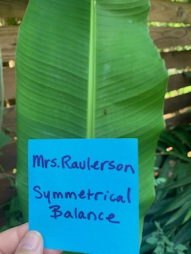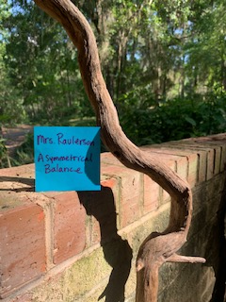

**Balance in Art and Design Handout**

Humans naturally seek out symmetry and, according to [Gestalt psychology](https://en.wikipedia.org/wiki/Gestalt_psychology#Pr.C3.A4gnanz), we tend to perceive objects as symmetrical shapes that form around a center point. That’s why balance is one of the key principles of design.

Visual balance is essential because it provides a sense of unity, order, and equilibrium. Your design needs to visually “hold together” in order to feel complete and harmonious. But to be clear, balance doesn’t mean everything should be perfectly symmetrical. It just means that the visual weight of objects, space, and color is equally distributed across the page. Without balance, a design feels off-kilter, inconsistent, and unsettling.

1. **Symmetrical Balance**

With symmetrical balance, you could draw a line down (or across) the middle of the project to create a mirror image. This perfect bilateral symmetry feels elegant, formal, and conservative.

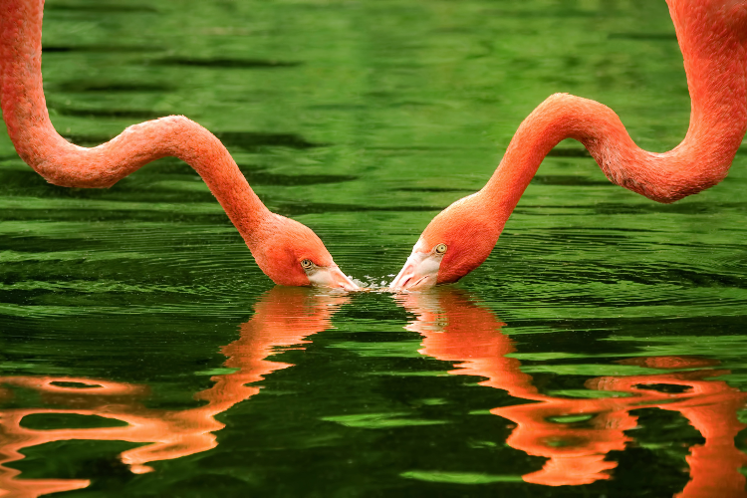

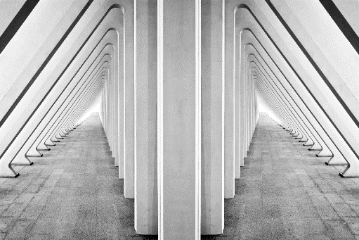

The images above illustrate how visual weight is very even and tidy on each side. Wedding invitations, theater programs, and poems are often cited as examples where symmetrical balance is used (think center aligned text and symmetrical layouts).

However, pure symmetrical balance can feel boring, dull, and constrained.

1. **Asymmetrical Balance**

Asymmetrical balance creates tension through contrast and is much more visually interesting. Because it’s abstract, there is no symmetry; there are no perfect mirror images. Instead, you’re arranging elements of all different visual weights in such a way that each side is still balanced out. The “heavier” elements will jump forward and catch the eye more than the “lighter” ones, which will recede.

This type of balance feels more casual, free, and energetic. To equalize the weight throughout your design, you can play around with these [different factors](http://www.smashingmagazine.com/2014/12/design-principles-visual-weight-direction/) that affect visual weight:

* **Size: Large items seem heavier than small**

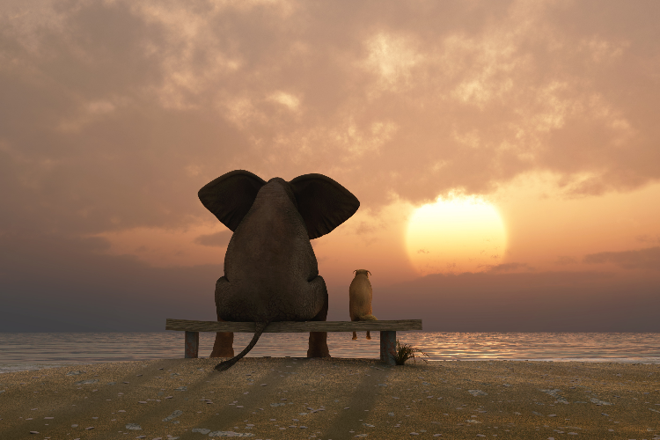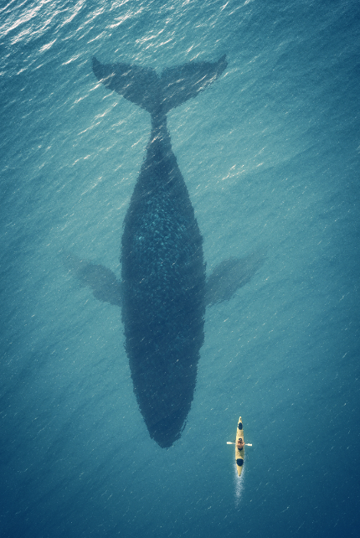

* **Value: Dark items feel heavier than light items.**

[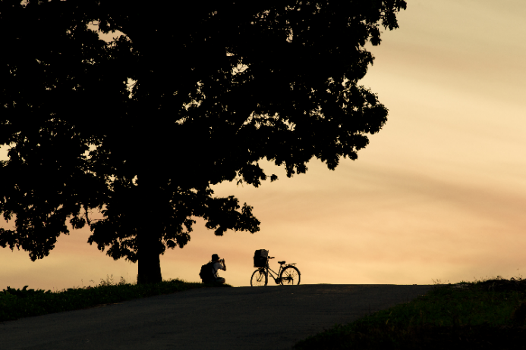](https://www.shutterstock.com/pic.mhtml?id=128183345?pl=CONTENT-blog&cr=balanceart&utm_source=CONTENT&utm_medium=blog&utm_content=balanceart&utm_campaign=blog)

* **Color: Warm, bright colors are more eye-catching than cool or neutral, muted ones. Red is considered to be the “heaviest” and yellow “lightest”**

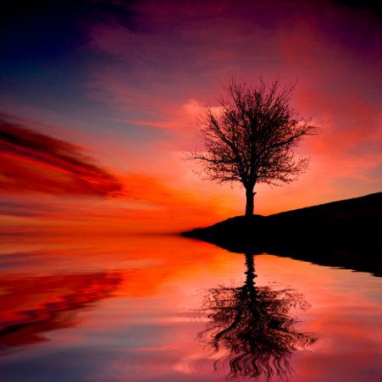

* **Texture: Objects with texture appear three-dimensional and feel physically heavier than objects without texture**

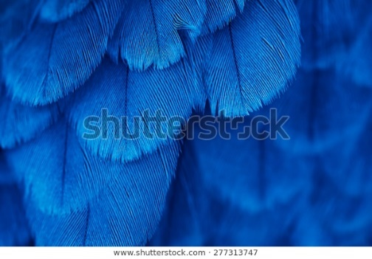

* **Quantity: A few small objects can balance out a single large object.**

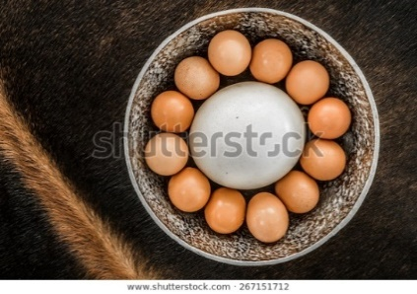

* **Isolation: An item by itself is more eye-catching than an item that’s one of many. (Wondering why? Think about**[**negative space**](https://www.shutterstock.com/blog/8-tips-for-maximizing-your-designs-with-negative-space)**.)**

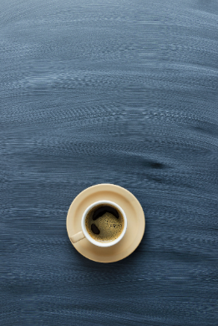**But make sure you balance your object with negative space.**

[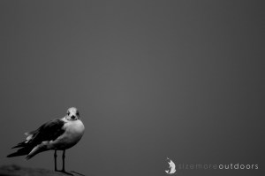](https://i0.wp.com/www.trentsizemore.com/wp-content/uploads/2012/08/IMG_5716.jpg?ssl=1)**The coffee cup is balanced but the seagull is not balanced. It is too far in the corner. This makes the seagull too heavy to create visual balance.**